Name: _________________

Date: __________________

**Warm Up 1.4 SHOW YOUR WORK!!!**

Solve the following problems by hand, use a graphing calculator to check:

1. Find the equation of the line going through the points (-3, -1) and (2,4). Answer in slope intercept form.

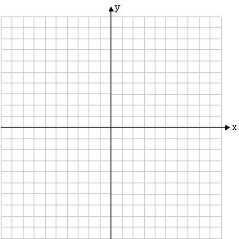2. Graph the equation x = -4

3. The producers of *Grey's Anatomy* are analyzing their show's ratings over two seasons to understand how viewership has changed. They recorded the following data:

* In Season 15, the average rating was 7.6 million viewers.
* In Season 18, the average rating dropped to 4.7 million viewers.

Let x be:

Let y be:

Find the slope. Round to the nearest hundredth. Interpret the slope in a complete sentence with units. HINT: Units is plural meaning more than one unit should be mentioned.

4. Let be a function.

Find $f(-x)$

Find $f(x+h)$